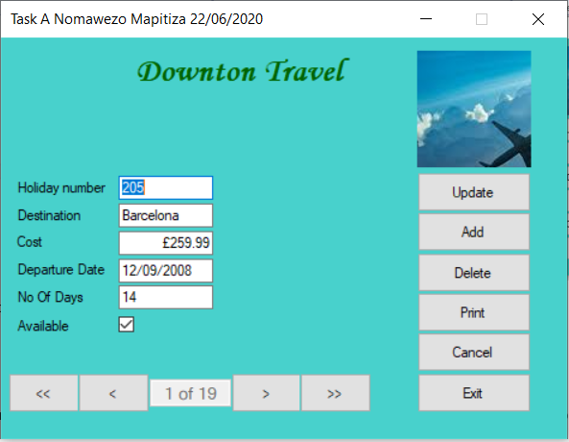

**Figure 1:** On execution of the application, the above screen displays the first record from the table.

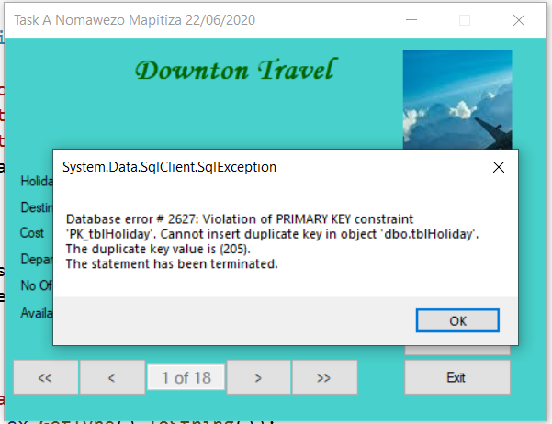

**Figure 2:** adding new record with the duplicate primary key.

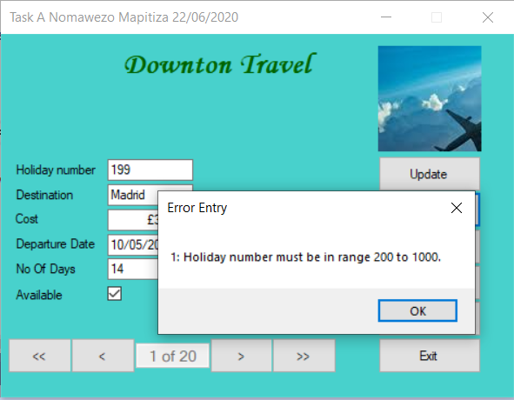

**Figure 3:** Adding a new record with Primary key out of acceptable specified range.

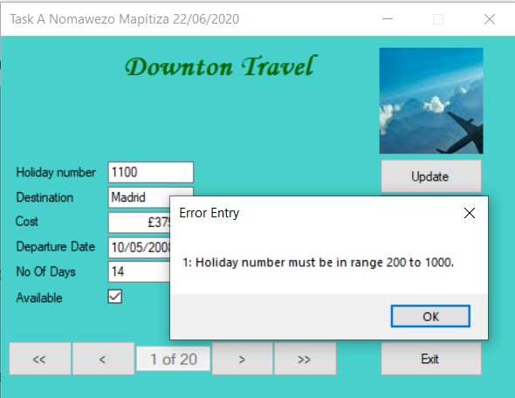

**Figure 4**: Adding a new record with Primary key out of acceptable range.

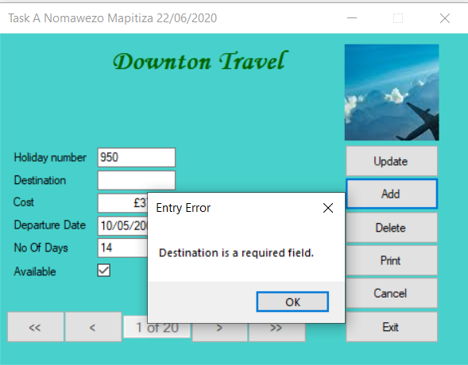

**Figure 5**: Adding a new record with destination input field empty out of acceptable range.

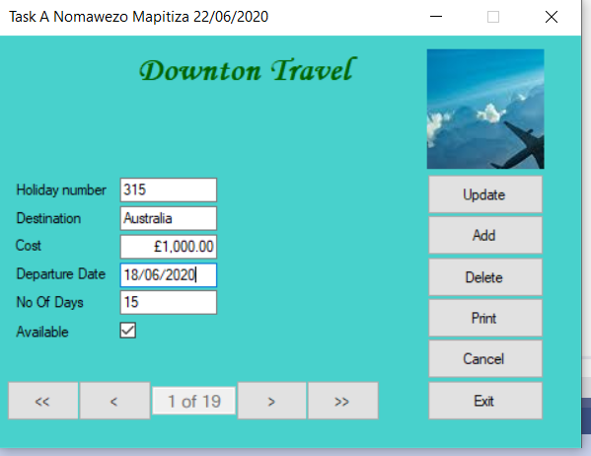

**Figure 6:** New record added.

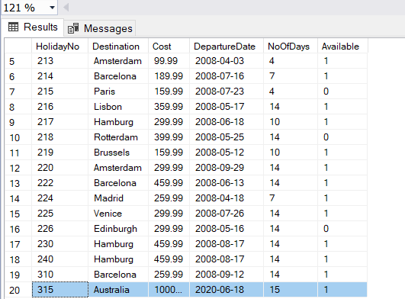

**Figure 7:** New record added to the table.

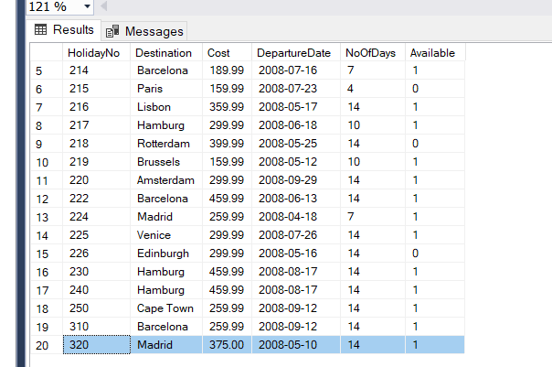

**Figure 8:** Shows the records in the table before the delete. The highlighted record is to be deleted.

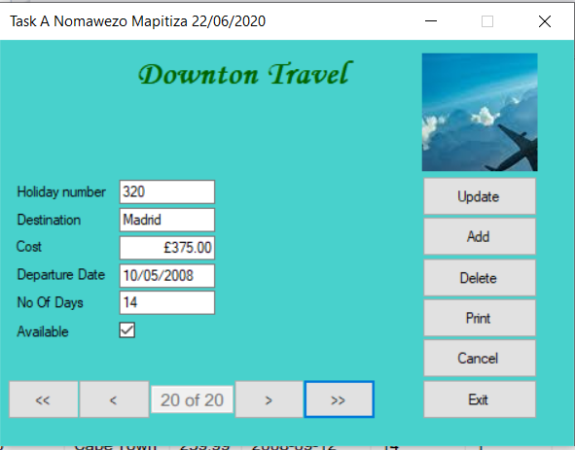

**Figure 9:** Record to be deleted using the form.

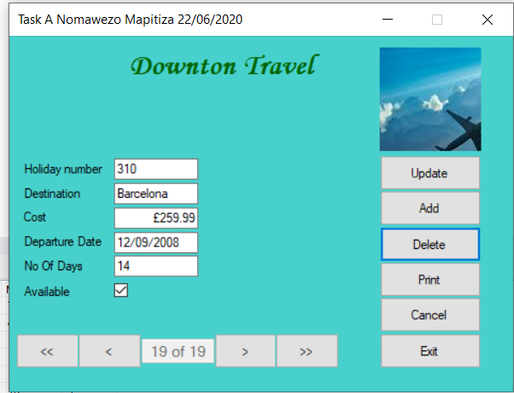

**Figure 10:** Previous record now displays after the delete.

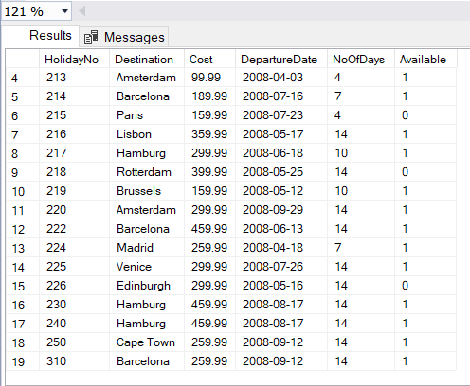

**Figure 11:** Record deleted from the table.

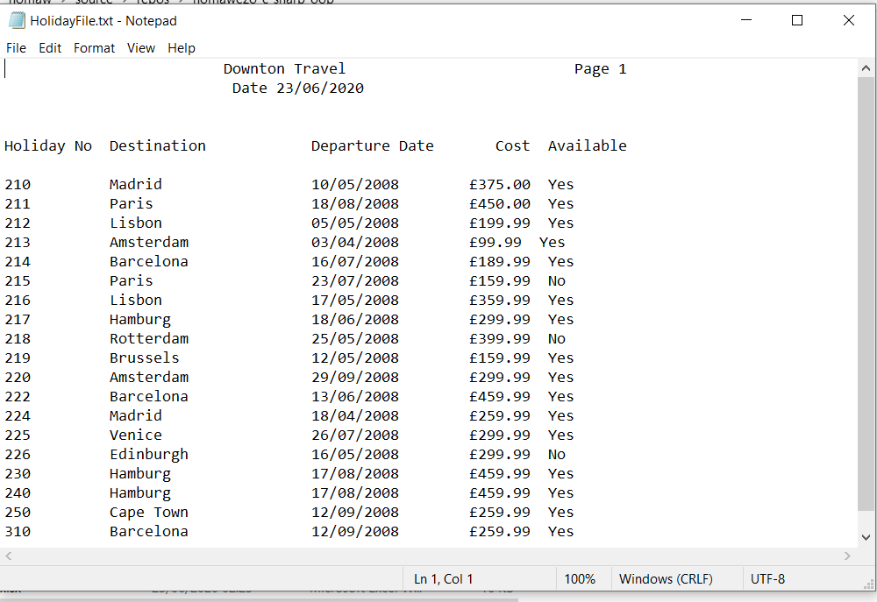

**Figure 12:** Records printed to text file.

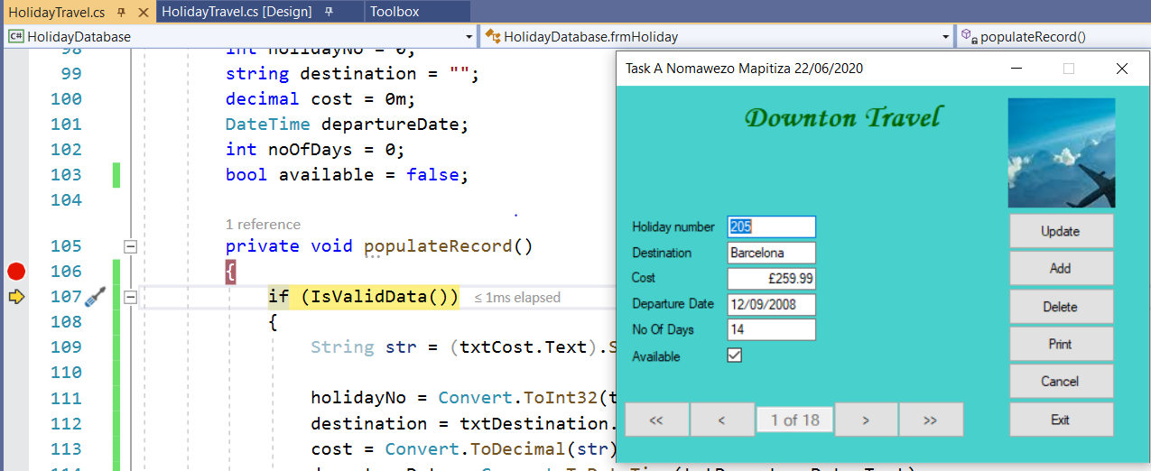

**Figure 13:** Breakpoint set on line 106.

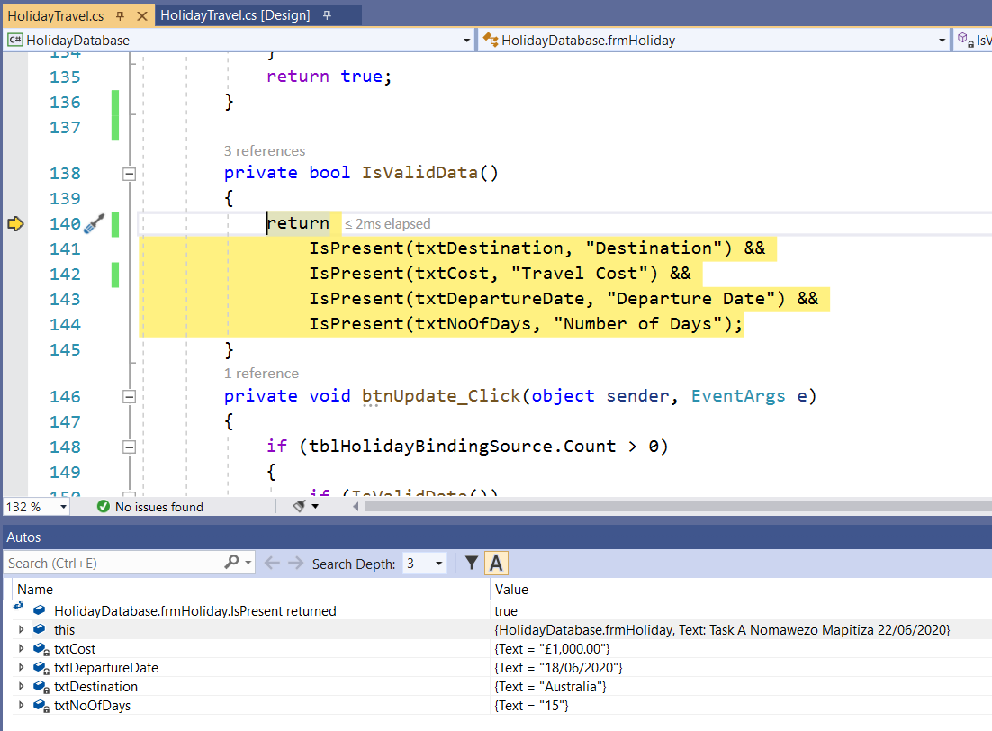

**Figure 14:** Debugging in process showing values for the input fields.

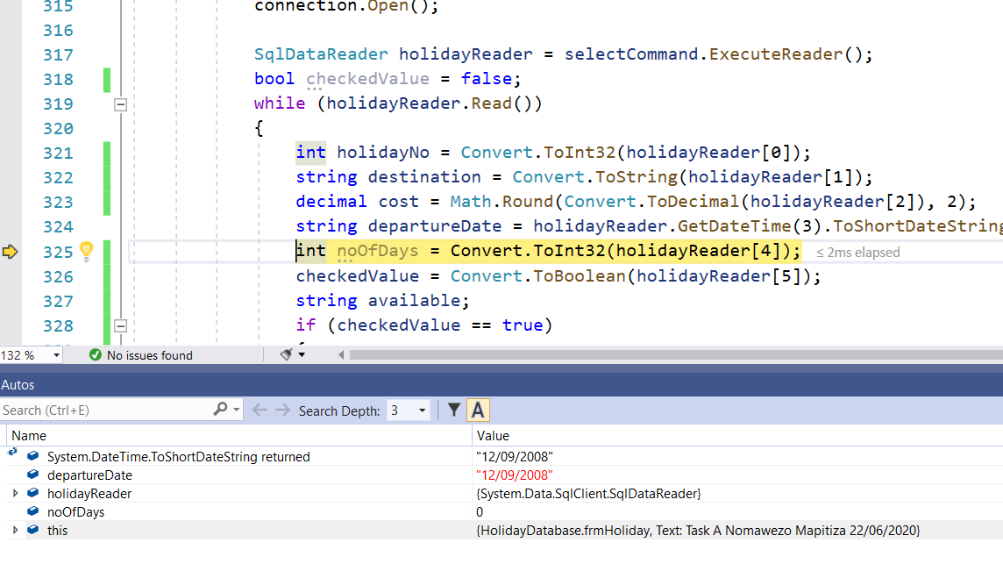

**Figure 15:** Shows formatted departureDate i.e. after ToShortDateString().